1. 200345 = 2*100000 + 0*10000 + 0*1000 + 3*100 + 4*10 + 5*1 = 2*10^5 + 0*10^4 + 0*10^3 + 3*10^2 + 4*10^1 + 5*10^0;

2.637

10->16 16->10

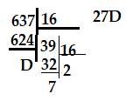 27D = 2*16^2 + 7*16^1 + 13*16^0 = 512+112+13 = 637;

3. 637

10->2 = 1001111101

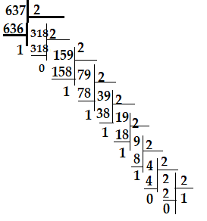

4. 11100111

2->10

11100111 = 1*2^7 + 1*2^6 + 1*2^5 + 0*2^4 + 0*2^3 +1*2^2 + 1*2^1 +1*2^0=128+64+32+0+0+4+2+1 = 231;

5. 637

10->3 = 212121

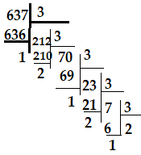

6.-12.

package lesson3;  
  
public class Elf {  
 private String flowers;  
 private int quantity;  
 private int id;  
 private double weight;  
 private int id2;  
 private int id3;  
  
 public static void main(String[] args) {  
  
 int quantity = 15;  
 String flowers = "snowdrops";  
 int id = 3;  
 double weight = 25.8;  
 int id2= 75;  
 int id3= 105;  
  
 System.*out*.println(flowers);  
 System.*out*.println(quantity);  
 System.*out*.println(id);  
 System.*out*.println(weight);  
 System.*out*.println(id2);  
 System.*out*.println(id3);  
 }  
 public String getFlowers(){  
 return flowers;  
 }  
 public void setFlowers(String flowers){  
 this.flowers = flowers;  
 }  
 public int getQuantity() {  
 return quantity;  
 }  
 public int getId() {  
 return id;  
 }  
 public double getWeight(){  
 return weight;  
 }  
 public int getId2 (){  
 return id2;  
 }  
 public int getId3 (){  
 return id3;  
 }  
 public void setQuantity(int quantity){  
 this.quantity = quantity;  
 }  
 public void setId(int id){  
 this.id = id;  
 }  
 public void setWeight(double weight){  
 this.weight = weight;  
 }  
 public void setId2(int id2){  
 this.id2 = id2;  
 }  
 public void setId3(int id3){  
 this.id3 = id3;  
 }  
  
 }

13.-14.

package lesson3;  
public class Constant {  
  
 public static void main(String[] args) {  
  
 final double ELF_POWER = 75.3;  
 System.*out*.println(ELF_POWER);  
  
 final int ELF_MAGIK = 37;  
 System.*out*.println(ELF_MAGIK);  
  
 // public static int elfCharisma = 68; // -не понимаю почему не работает  
 // System.out.println(elfCharisma);  
 }  
}

package lesson3;  
  
public class HomeWork3 {  
  
 public static void main(String[] args) {  
  
 String word ="I study Basic Java!";  
  
 System.*out*.println(word);  
 System.*out*.println(word.charAt(18));  
 System.*out*.println(word.contains("Java"));  
 System.*out*.println(word.replace('a', 'o'));  
 System.*out*.println(word.toUpperCase());  
 System.*out*.println(word.toLowerCase());  
 System.*out*.println(word.substring(0, 13));  
  
 }  
}